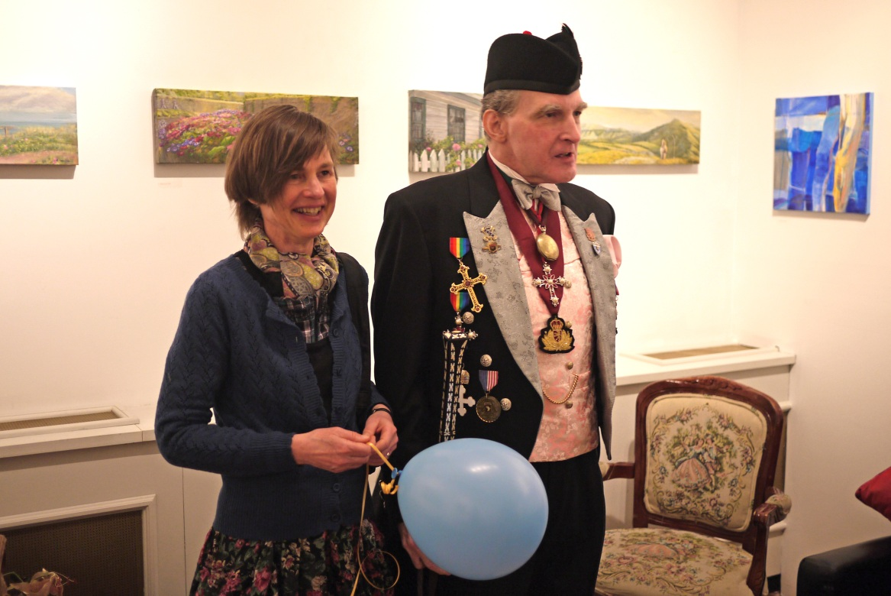
Vad Amsterdam Whitney Gallery i New York tycker om min konst:
Claude Monet once advised, “Paint what you really see, not what you think you ought to see; not the object isolated as in a test tube, but the object enveloped in sunlight and atmosphere, with the blue dome of Heaven reflected in the shadows.”
Like Monet, Contemporary artist Anne Hauger paints beautiful landscapes brimming with the spirit, color, and light of the artist's impression.
Ms. Hauger's stunning depictions of the world around her effortlessly transport the viewer to idyllic locales throughout Europe and New Zealand.
The very essence of each location exudes from the beautiful tableaus, filling the spectator's space with the scent of fresh spring blooms, the caress of the late afternoon sunlight and the sound of the waves lapping the shore. Ms. Hauger crafts this alluring atmosphere through her masterful coloration and textural brushstrokes.
She skillfully manipulates the acrylic medium, working with quick staccato brushstrokes that seem to lift right off the canvas. By layering the paint in this Impressionist manner, Ms. Hauger allows her colors to sing with unparalleled vivacity.
The artist carefully balances bursts of pure color with ethereal highlights, creating a welcoming aura of warm natural light that emanates from each of her scenes. Ms. Hauger's works are captivating and timeless, elevating the mind and spirit through their soothing aesthetic splendor.
Sweden-based artist Anne Hauger has been painting professionally for more than two decades. She has exhibited extensively in Europe and her work is held in several university and government collections.
Amsterdam Whitney Gallery is proud to spotlight her exceptional artwork.
Vänd!

Om galleriet och dess ägare, Ruthie Tucker:
AMSTERDAM WHITNEY International Fine Art, Inc. was established as a premier vanguard gallery in direct response to the discerning taste and trends of the sophisticated worldwide collector, searching to discover foremost cutting edge contemporary artists
who will be the trailblazer Contemporary Masters into the twentyfirst century, showcasing them in a museum forum environment.
Amsterdam Whitney Gallery bears the distinguished family name Ambassador Dr. Alton Amsterdam III, which is emblematic of the highest standards of excellence, offering both artists and collectors alike the highest pedigree.

Owner, Executive Director-Curator, Ruthie Tucker, M.A., reflects 40 years of consummate art world experience and highest academic expertise, including executive positions at the Guggenheim Museum, Phillips International Auction House, elite Madison Avenue Galleries and years as a pre-eminent New York Art Dealer.
Dedicated to being a passionate "Advocate of the Artist," and widely recognized as being a catalyst in establishing the careers of a pantheon of artists, she and her co-owner husband, Ambassador Dr. Alton Louis Amsterdam III, created AMSTERDAM WHITNEY International Fine Art to be a dynamic, pro active, exciting museum quality environment which caters both to the nurturing promotional needs of the artist, as well as to the precise aesthetic demands of the informed collector and the respected art professional.

